Technical requirements specification

This document contains requirements regarding exterior view of Putnil2 watch components. It constitutes supplementary clarification of client requirements and can’t be alienated from provided drawings and 3D models of watch parts.

1_Dial
1.1 Painting coverage should not have any defects like scratches and paint lumps. Visual control must be done with x5 magnifier (but not with naked eye!)
1.2 All the elements of pad printing must have volume and carried out in embossing technic
1.3.Pad printing elements must have clear, distinct edges without paint splashes and leaks (spider legs).
1.4 Glowing indexes. Glowing indexes. There are scheme shown, the indexes (number3) are supposed to glow in darkness. It should be superluminova glowing parts, at the figure 4 presented an example of shining intensity. This intensity must be provided during at least 30 minutes
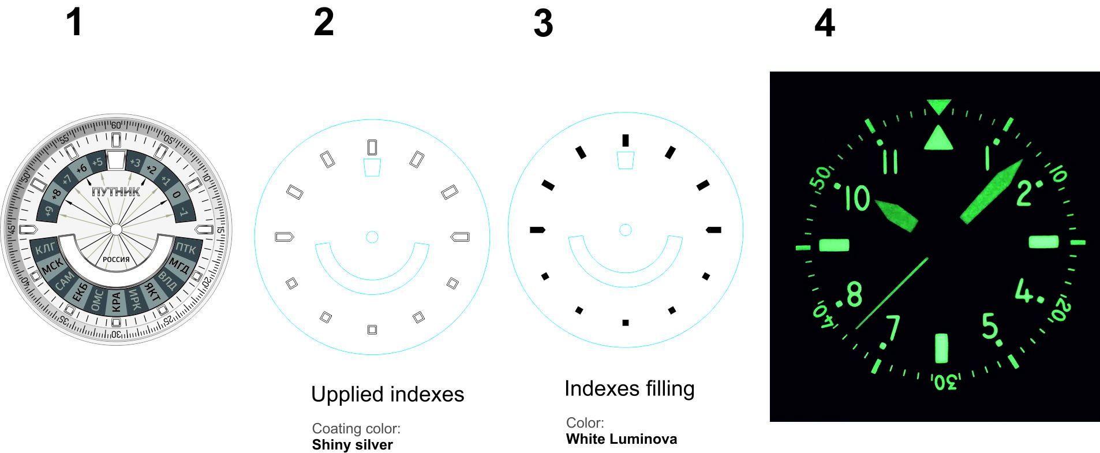

2_Hands
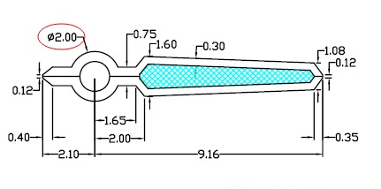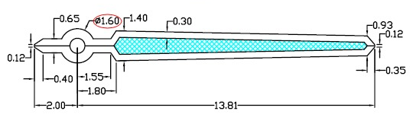
2.1 Scratches or junk are not allowed at the all surface of hands
2.2 Inner area is filled in with superluminova and all the requirements listed in the item 1.4 are applicable here. Especially requirements about glowing in darkness.

3_Watch case
3.1 Any scratches or dents are not allowed at the all surface of watch case and bracelet
3.2 All the edges must have distinct, clear margins without roundings and corner damages. The most crucial places are marked with red arrows
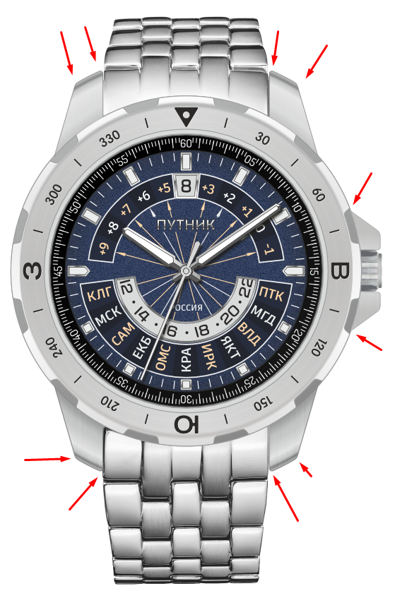
4_Strap

4.1 Any scratches or cracks are not allowed
4.2 Stitching must be done neat and accurate without fluffy margins.
4.3 Endings of stitching must be fixed as sneaky as it is possible.

5_Metal bracelet
All the requirements for watch case are applicable for bracelet.

6_Watch box
Any kinds of damages (cracks, crumpled corners and etc) of box surfaces are not allowed .

